**The Oracle DB & MySQL databases to Azure SQL Databases:**

**Migration Plan:** Oracle Database to Azure SQL Database

**Pre-migration:**

* Assess
* Validate the data types
* Convert the schema

**Recommended Migration tool:**

* Azure Data Studio

**Architecture of Azure SQL migration extension for Azure Data Studio**

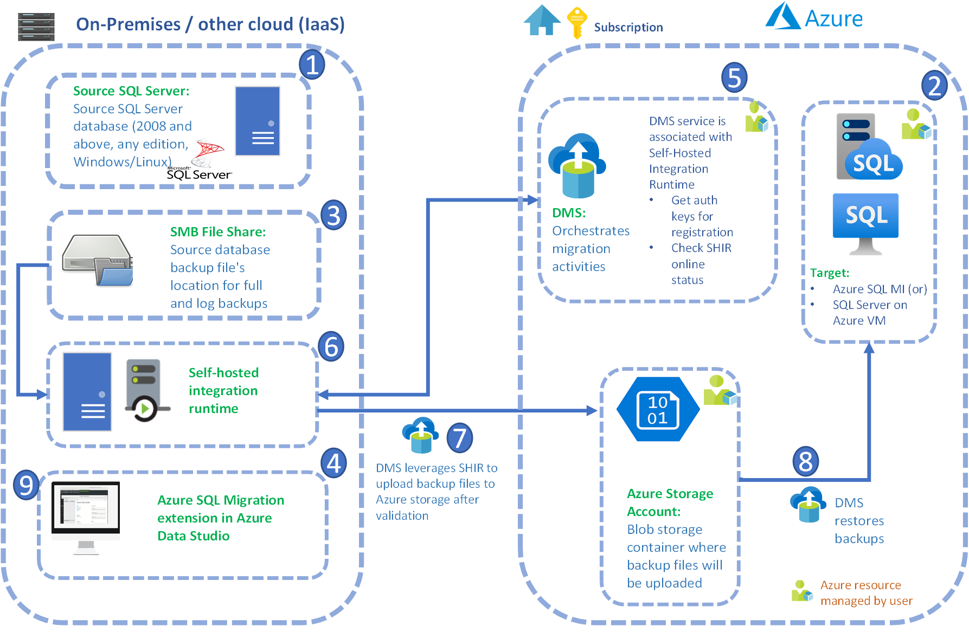

**Post migration:**

**Performance data collection and SKU recommendation**

